SIMATS ENGINEERING
ASSESSMENT TOOL 1
Experiments

NAME: Siva Dakshitha K REG.NO:192425395
COURSE NAME: Computer Networks COURSE CODE: CSA0703

COURSE OUTCOME COVERED

CO3: Analyze the performance of core network protocols such as TCP, UDP, HTTP, and DNS under varying conditions
Assessment Tool Weightage: 40%
SOFTWARE: CISCO PACKET TRACER, WIRESHARK

EXPERIMENTS

QUESTIONS:4 Total Marks:40

- Design a simple LAN consisting of two PCs connected through a switch using Cisco Packet Tracer. Configure appropriate IP addresses for both hosts and verify connectivity using the ping command. Simultaneously capture the packet exchange using Wireshark. Identify the Ethernet frame fields such as Source MAC Address, Destination MAC Address, EtherType, and Frame Check Sequence (FCS). Explain how the Data Link layer uses MAC addressing to ensure successful frame delivery within the local network.
ANS:
Aim:
To design a simple Local Area Network (LAN) using two PCs connected through a switch, configure IP addresses, verify connectivity using the ping command, and analyze Ethernet frame fields using Wireshark.

Software Required
- Cisco Packet Tracer
- Wireshark

Devices Required
- 2 PCs
- 1 Switch (Cisco 2960)
- 2 Copper Straight-Through Cables

Network Topology
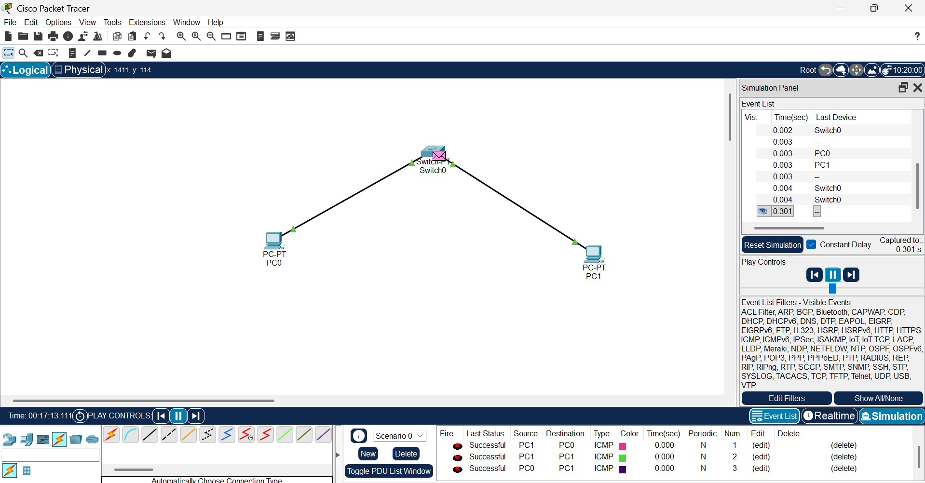
IP Addressing Table
Device | IP Address | Subnet Mask
PC0 | 192.168.1.1 | 255.255.255.0
PC1 | 192.168.1.2 | 255.255.255.0
Procedure
- Open Cisco Packet Tracer.
- Place one Cisco 2960 switch and two PCs in the workspace.
- Connect both PCs to the switch using Copper Straight-Through cables.
- Configure the IP addresses:
  - PC0 → 192.168.1.1
  - PC1 → 192.168.1.2
- Open the Command Prompt on PC0.
- Execute the command:
ping 192.168.1.2
- Verify that the ping is successful.
- Open Wireshark and select the active Ethernet interface.
- Start packet capture.
- Perform the ping again.
- Stop the packet capture.
- Observe the captured Ethernet frame and identify the required fields.
Observation
- Both PCs were successfully connected through the switch.
- The assigned IP addresses were in the same network.
- The ping command was successful with no packet loss.
- Wireshark captured the Ethernet and ICMP packets.
- The Ethernet frame displayed the Source MAC Address, Destination MAC Address, EtherType, and Frame Check Sequence (FCS).

Ethernet Frame Analysis
Field | Description
Source MAC Address | The physical (MAC) address of the sender (PC0).
Destination MAC Address | The physical (MAC) address of the receiver (PC1).
EtherType | Indicates the protocol encapsulated in the Ethernet frame. For IPv4, the EtherType value is 0x0800.
Frame Check Sequence (FCS) | A CRC value used to detect transmission errors. If the calculated FCS matches the received value, the frame is accepted; otherwise, it is discarded.

Role of the Data Link Layer:
The Data Link Layer (Layer 2 of the OSI model) is responsible for reliable communication within a local network. It uses MAC addresses to uniquely identify devices connected to the LAN. When PC0 sends data to PC1, the Ethernet frame contains the source and destination MAC addresses. The switch checks the destination MAC address and forwards the frame only to the correct port where PC1 is connected. This ensures accurate and efficient frame delivery within the network.
Analysis:
The successful ping confirms that both PCs are correctly configured and can communicate within the same LAN. Wireshark captures the Ethernet frames exchanged during communication. The Source MAC Address identifies the sender, while the Destination MAC Address identifies the receiver. The EtherType value 0x0800 indicates that the payload contains an IPv4 packet. The FCS verifies the integrity of the frame by detecting transmission errors. This analysis demonstrates how the Data Link layer enables reliable communication between devices on the same network.
Result:
A simple LAN was successfully designed and configured using Cisco Packet Tracer. Communication between the two PCs was verified using the ping command. Wireshark successfully captured the Ethernet frames, and the Source MAC Address, Destination MAC Address, Ether Type, and Frame Check Sequence (FCS) were identified and analyzed.
Conclusion:
The experiment successfully demonstrated communication between two hosts in a Local Area Network. The Data Link Layer uses MAC addresses to ensure correct frame delivery within the LAN. Cisco Packet Tracer was used to configure the network, while Wireshark was used to capture and analyze the Ethernet frames, providing a clear understanding of Layer 2 communication.

- Create a network topology consisting of two LANs connected through a router in Cisco Packet Tracer. Configure IPv4 addressing, subnet masks, and default gateways for all devices, and verify end-to-end communication using the ping command. Capture the ICMP packets using Wireshark and analyze the IPv4 header fields, including Source IP Address, Destination IP Address, Time-To-Live (TTL), Protocol Number, and Header Length. Explain the role of the Network layer in forwarding packets between different networks.
ANS:
Aim
To create two LANs connected through a router, configure IPv4 addressing, verify communication using the ping command, and analyze IPv4 header fields using Wireshark.
Software Required
- Cisco Packet Tracer
- Wireshark
Devices Required
- 2 PCs
- 2 Switches (2960)
- 1 Router (1941/2911)
- Copper Straight-Through Cables
Network Topology
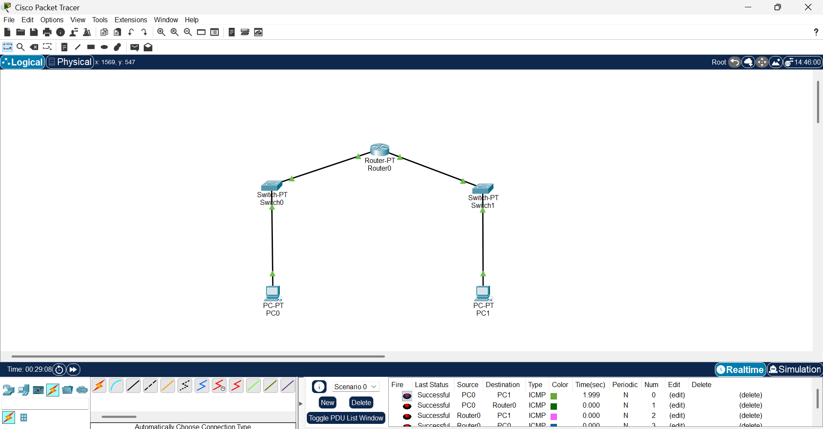IP Addressing Table
Device | Interface | IP Address | Subnet Mask | Default Gateway
PC0 | FastEthernet0 | 192.168.1.2 | 255.255.255.0 | 192.168.1.1
Router | GigabitEthernet0/0 | 192.168.1.1 | 255.255.255.0 | -
Router | GigabitEthernet0/1 | 192.168.2.1 | 255.255.255.0 | -
PC1 | FastEthernet0 | 192.168.2.2 | 255.255.255.0 | 192.168.2.1
Procedure
- Open Cisco Packet Tracer.
- Place one router, two switches, and two PCs.
- Connect PC0 to Switch0 and PC1 to Switch1.
- Connect both switches to the router.
- Configure the IP addresses on the PCs.
- Configure the router interfaces with the required IP addresses.
- Set the default gateway on each PC.
- Verify connectivity using the ping command.
- Start Wireshark and capture the ICMP packets.
- Analyze the IPv4 header fields.

Router Configuration
Router> enable
Router# configure terminal

Router(config)# interface g0/0
Router(config-if)# ip address 192.168.1.1 255.255.255.0
Router(config-if)# no shutdown
Router(config-if)# exit

Router(config)# interface g0/1
Router(config-if)# ip address 192.168.2.1 255.255.255.0
Router(config-if)# no shutdown
Router(config-if)# end
Observation
- Both LANs were successfully connected through the router.
- IP addresses and default gateways were configured correctly.
- The ping between PC0 and PC1 was successful.
- Wireshark captured the ICMP packets exchanged between the two hosts.
IPv4 Header Analysis
Header Field | Description
Source IP Address | IP address of the sender (e.g., 192.168.1.2).
Destination IP Address | IP address of the receiver (e.g., 192.168.2.2).
Time-To-Live (TTL) | Limits the lifetime of a packet. It decreases by 1 at each router to prevent infinite looping.
Protocol Number | Identifies the upper-layer protocol. For ICMP, the protocol number is 1.
Header Length | Indicates the size of the IPv4 header, usually 20 bytes.
Role of the Network Layer
The Network Layer (Layer 3 of the OSI model) is responsible for routing packets between different networks using IP addresses. The router examines the destination IP address, selects the best path, and forwards the packet to the appropriate network. It also decreases the TTL value at each hop to prevent packets from circulating indefinitely.
Analysis
The successful ping confirms that the router correctly forwards packets between the two LANs. The captured ICMP packets in Wireshark show the source and destination IP addresses used for communication. The TTL field decreases when the packet passes through the router, while the Protocol field identifies ICMP. The IPv4 header provides all the information required for routing and delivery of packets across different networks.
Result
Two LANs were successfully connected using a router. Communication between the hosts was verified using the ping command. The IPv4 header fields were captured and analyzed using Wireshark, demonstrating the role of the Network layer in packet forwarding.
Conclusion
The experiment demonstrated successful communication between two different networks using a router. The Network Layer used IP addressing and routing to forward packets, while Wireshark provided detailed information about the IPv4 header fields. This experiment helped in understanding the operation of Layer 3 communication and packet routing.

- Construct a local area network with multiple hosts connected through a switch in Cisco Packet Tracer. Clear the ARP cache on one of the hosts and initiate communication with another host using the ping command. Capture the communication in Wireshark and identify the ARP Request and ARP Reply packets. Analyze the sender and target MAC/IP addresses and explain how the Address Resolution Protocol resolves logical IP addresses into physical MAC addresses before data transmission.
ANS:
Aim
To construct a Local Area Network (LAN) with multiple hosts connected through a switch using Cisco Packet Tracer, clear the ARP cache, verify communication using the ping command, capture ARP packets using Wireshark, and analyze how ARP resolves IP addresses into MAC addresses.
Network Topology
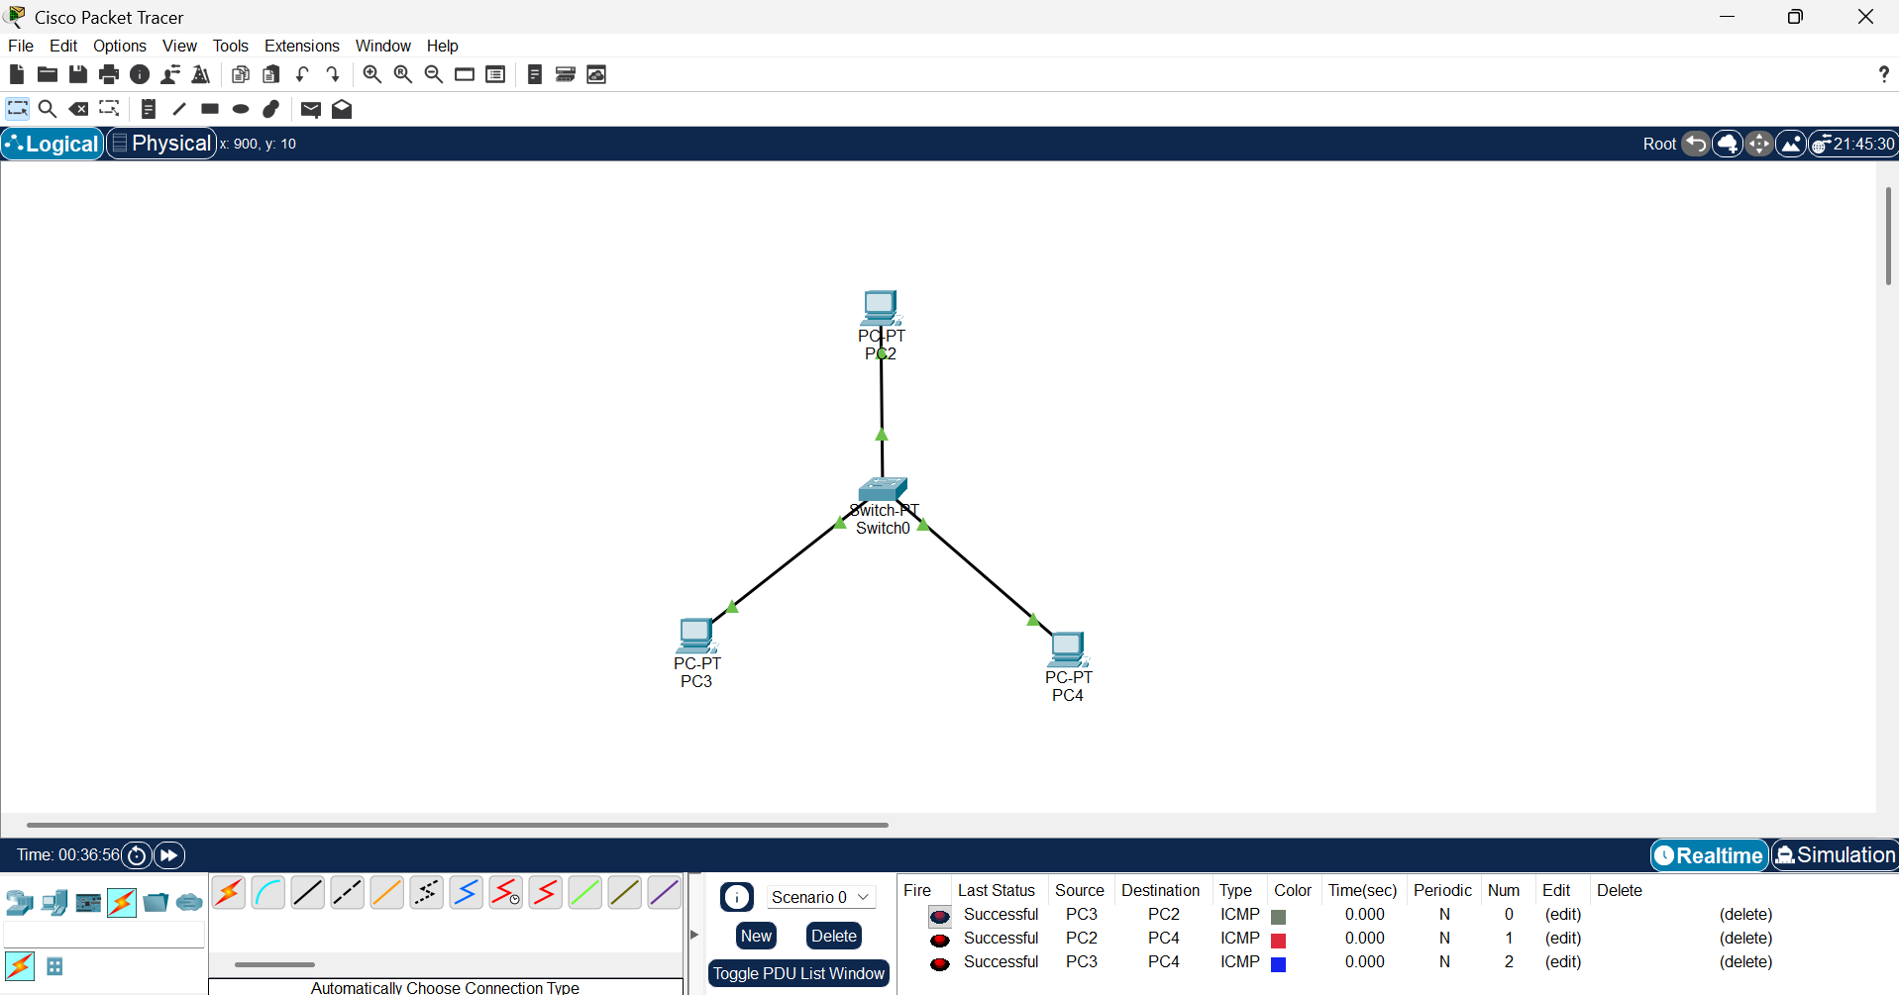

All PCs are connected to the same switch using Copper Straight-Through cables.
IP Address Configuration
Device | IP Address | Subnet Mask | Default Gateway
PC0 | 192.168.1.2 | 255.255.255.0 | 192.168.1.1
PC1 | 192.168.1.3 | 255.255.255.0 | 192.168.1.1
PC2 | 192.168.1.4 | 255.255.255.0 | 192.168.1.1

Implementation Steps in Cisco Packet Tracer
Step 1: Create the Network
- Open Cisco Packet Tracer.
- Place one 2960 switch and three PCs.
- Connect each PC to the switch using Copper Straight-Through cables.
Step 2: Configure IP Addresses
For each PC:
Desktop → IP Configuration
Assign the IP addresses shown in the table above.
Step 3: Clear the ARP Cache
On PC0:
Desktop → Command Prompt
Execute:
arp -d
This deletes the existing ARP entries.
Step 4: Verify the ARP Cache
Type:
arp -a
The ARP table should be empty (or contain very few entries).
Step 5: Generate Communication
From PC0, execute:
ping 192.168.1.3
(Packet Tracer may show the first ping timing out while ARP resolution occurs. Subsequent replies should succeed.)
Step 6: Verify the ARP Table
After the ping completes, execute:
arp -a
Now the ARP table will contain an entry similar to:
Internet Address Physical Address
192.168.1.3 00D0.BA45.1234
(The MAC address will vary.)
Capturing ARP Packets Using Wireshark
- Open Wireshark.
- Select the active network interface.
- Click Start Capture.
- Execute the ping command from PC0.
- Stop the capture.
- Apply the display filter:
arp
The captured packets will display:
- ARP Request
- ARP Reply
Analysis of ARP Packets
ARP Request
Field | Description
Sender IP Address | 192.168.1.2
Sender MAC Address | MAC Address of PC0
Target IP Address | 192.168.1.3
Target MAC Address | 00:00:00:00:00:00 (Unknown)
The request is broadcast to all devices asking:
"Who has IP address 192.168.1.3? Tell 192.168.1.2."
ARP Reply
Field | Description
Sender IP Address | 192.168.1.3
Sender MAC Address | MAC Address of PC1
Target IP Address | 192.168.1.2
Target MAC Address | MAC Address of PC0
PC1 replies directly to PC0 with its MAC address.
Working of Address Resolution Protocol (ARP)
The Address Resolution Protocol (ARP) resolves a logical IPv4 address into a physical MAC address before data transmission within the same LAN.
The process is:
- PC0 wants to send data to PC1.
- PC0 checks its ARP cache.
- If no MAC address exists, it sends an ARP Request as a broadcast.
- All hosts receive the request.
- Only PC1 recognizes its IP address.
- PC1 sends an ARP Reply containing its MAC address.
- PC0 stores the MAC address in its ARP cache.
- Data is then transmitted using Ethernet frames with the correct destination MAC address.
Result
A Local Area Network consisting of multiple hosts connected through a switch was successfully created in Cisco Packet Tracer. The ARP cache was cleared, and communication was initiated using the ping command. The ARP Request and ARP Reply packets were captured and analyzed in Wireshark. The sender and target MAC/IP addresses were identified, demonstrating how the Address Resolution Protocol (ARP) resolves logical IP addresses into physical MAC addresses before data transmission.

- Develop a simple network consisting of two PCs connected through a router in Cisco Packet Tracer. Configure the required IP addresses and test connectivity using the ping command. Capture the ICMP traffic using Wireshark and identify the Echo Request and Echo Reply messages. Examine important ICMP fields such as Type, Code, Identifier, and Sequence Number, and calculate the Round Trip Time (RTT). Discuss how ICMP assists in network troubleshooting and connectivity verification.
ANS:
Aim
To develop a simple network consisting of two PCs connected through a router in Cisco Packet Tracer, configure IPv4 addressing, verify communication using the ping command, capture ICMP packets using Wireshark, analyze ICMP header fields, calculate the Round Trip Time (RTT), and understand the role of ICMP in network troubleshooting.
Network Topology
The network consists of two Personal Computers (PC0 and PC1) connected through a router. Each PC belongs to a different subnet, and the router enables communication between these two networks. A switch may be used on each side to connect the PCs to the router.
Topology Diagram
IP Address Configuration
Device | IP Address | Subnet Mask | Default Gateway
PC0 | 192.168.1.2 | 255.255.255.0 | 192.168.1.1
Router G0/0 (or Fa0/0) | 192.168.1.1 | 255.255.255.0 | —
Router G0/1 (or Fa1/0) | 192.168.2.1 | 255.255.255.0 | —
PC1 | 192.168.2.2 | 255.255.255.0 | 192.168.2.1

Implementation Steps in Cisco Packet Tracer
Step 1: Create the Network
- Open Cisco Packet Tracer.
- Place one Router, two Switches, and two PCs.
- Connect:
  - PC0 → Switch0
  - Switch0 → Router
  - Router → Switch1
  - Switch1 → PC1
- Use Copper Straight-Through cables.
Step 2: Configure Router
enable
configure terminal

interface FastEthernet0/0
ip address 192.168.1.1 255.255.255.0
no shutdown
exit

interface FastEthernet1/0
ip address 192.168.2.1 255.255.255.0
no shutdown
exit

end
write memory
Step 3: Configure PCs
PC0
- IP Address: 192.168.1.2
- Subnet Mask: 255.255.255.0
- Default Gateway: 192.168.1.1
PC1
- IP Address: 192.168.2.2
- Subnet Mask: 255.255.255.0
- Default Gateway: 192.168.2.1
Step 4: Verify Connectivity
From PC0, open Desktop → Command Prompt and execute:
ping 192.168.2.2
If the configuration is correct, four replies will be received successfully.
Capturing ICMP Packets Using Wireshark
- Open Wireshark.
- Select the active network interface.
- Start packet capture.
- Execute the ping command.
- Stop the capture.
- Apply the filter:
icmp
The capture will display:
- ICMP Echo Request
- ICMP Echo Reply
Analysis of ICMP Header Fields
Field | Sample Value | Description
Type | 8 | Echo Request sent by the source host
Type | 0 | Echo Reply returned by the destination host
Code | 0 | Indicates a normal Echo Request/Reply message
Identifier | Example: 0x0001 | Matches request and reply packets
Sequence Number | 1, 2, 3, 4 | Identifies each ping packet
Round Trip Time (RTT) | <1 ms (or measured value) | Time taken for a packet to travel to the destination and back

Round Trip Time (RTT)
RTT is the total time required for an ICMP Echo Request to travel from the source to the destination and for the Echo Reply to return.
Formula:
RTT = Time of Echo Reply − Time of Echo Request
Example:
- Echo Request Time = 0.001 s
- Echo Reply Time = 0.003 s
RTT = 0.002 seconds (2 ms)
Role of ICMP in Network Troubleshooting
The Internet Control Message Protocol (ICMP) is used to diagnose and troubleshoot network communication.
Its functions include:
- Verifying connectivity between hosts using the ping command.
- Detecting unreachable hosts or networks.
- Measuring network delay using RTT.
- Identifying packet loss.
- Assisting administrators in troubleshooting routing and communication problems.
- Supporting diagnostic tools such as ping and traceroute.
ICMP does not transport application data; instead, it provides error reporting and diagnostic information.
Result
A simple network consisting of two PCs connected through a router was successfully created in Cisco Packet Tracer. IPv4 addressing was configured correctly, and communication was verified using the ping command. The ICMP Echo Request and Echo Reply packets were captured and analyzed in Wireshark. Important ICMP fields such as Type, Code, Identifier, Sequence Number, and Round Trip Time (RTT) were examined, demonstrating how ICMP assists in network troubleshooting and connectivity verification.

- Create a client-server network in Cisco Packet Tracer by configuring a web server and a client PC. Enable the HTTP service on the server and access the hosted webpage from the client using a web browser. Capture the communication in Wireshark and identify the TCP three-way handshake, followed by the HTTP GET request and HTTP response messages. Analyze the application-layer communication and explain how TCP provides reliable delivery for HTTP traffic through connection establishment, acknowledgments, and ordered data transfer.
ANS:
Aim
To create a client-server network in Cisco Packet Tracer by configuring a Web Server and a Client PC, enable the HTTP service on the server, access the hosted webpage using a web browser, capture the communication using Wireshark, analyze the TCP three-way handshake and HTTP communication, and understand how TCP provides reliable data delivery.
Network Topology
The network consists of one Web Server, one Client PC, and one Switch. Both the client and the server are connected to the same switch using Copper Straight-Through cables. The client accesses the web page hosted on the server through the HTTP protocol.
Topology Diagram
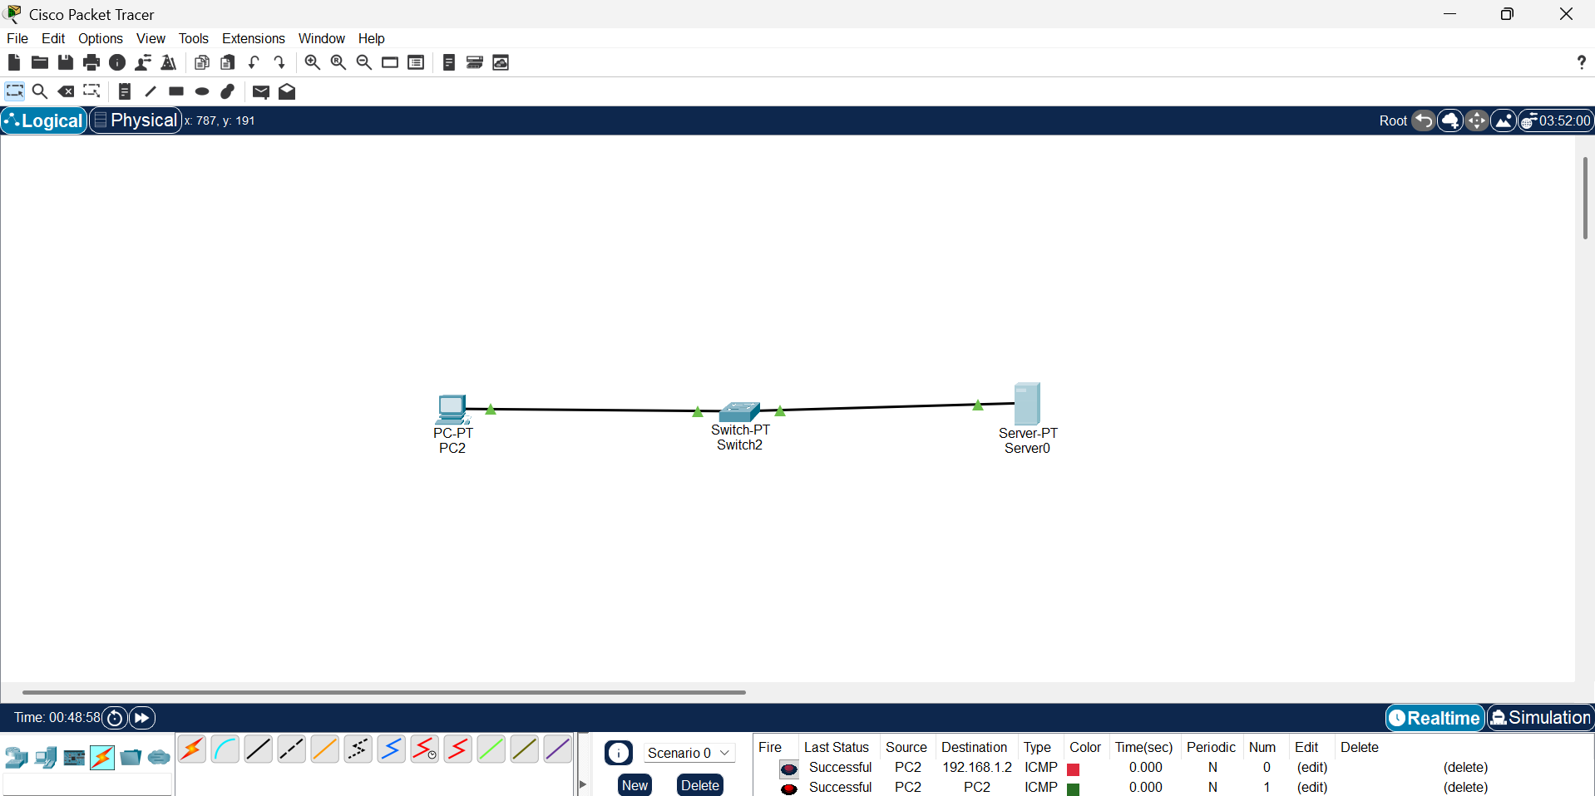
IP Address Configuration
Device | IP Address | Subnet Mask | Default Gateway
Client PC | 192.168.1.2 | 255.255.255.0 | 192.168.1.1
Web Server | 192.168.1.10 | 255.255.255.0 | 192.168.1.1

Implementation Steps in Cisco Packet Tracer
Step 1: Create the Network
- Open Cisco Packet Tracer.
- Place one 2960 Switch, one PC, and one Server.
- Connect both devices to the switch using Copper Straight-Through cables.
Step 2: Configure IP Addresses
Client PC
- IP Address: 192.168.1.2
- Subnet Mask: 255.255.255.0
- Default Gateway: 192.168.1.1
Web Server
- IP Address: 192.168.1.10
- Subnet Mask: 255.255.255.0
- Default Gateway: 192.168.1.1
Step 3: Enable HTTP Service
On the Server:
- Open Services tab.
- Select HTTP.
- Turn HTTP Service = ON.
- Leave the default webpage or edit index.html if required.
Step 4: Access the Webpage
On the Client PC:
Desktop → Web Browser
Enter:
http://192.168.1.10
The default web page hosted on the server should appear successfully.
Capturing Packets Using Wireshark
- Open Wireshark.
- Select the active network interface.
- Start packet capture.
- Open the webpage from the client.
- Stop packet capture.
- Apply the display filter:
http || tcp
Analysis of TCP Three-Way Handshake
Before HTTP communication begins, TCP establishes a reliable connection.
Step 1: SYN
Client → Server
- SYN = 1
- Requests connection establishment.
Step 2: SYN-ACK
Server → Client
- SYN = 1
- ACK = 1
- Accepts the connection request.
Step 3: ACK
Client → Server
- ACK = 1
- Connection established successfully.
HTTP Communication
After the TCP connection is established:
HTTP GET Request
Client sends:
GET / HTTP/1.1
This requests the default webpage from the server.
HTTP Response
Server replies:
HTTP/1.1 200 OK
The server sends the requested webpage (HTML content) to the client.
Application Layer Communication
The communication follows this sequence:
- Client enters the server IP in the web browser.
- TCP establishes a reliable connection using the three-way handshake.
- The client sends an HTTP GET request.
- The server processes the request.
- The server sends an HTTP Response.
- The browser displays the webpage.
Role of TCP in Reliable HTTP Communication
TCP provides reliable communication through:
- Connection establishment using the three-way handshake.
- Sequence numbers for ordered delivery.
- Acknowledgement (ACK) messages.
- Error detection using checksums.
- Retransmission of lost packets.
- Flow control to prevent congestion.
- Guaranteed in-order delivery of data.
These mechanisms ensure that HTTP webpages are delivered accurately without data loss.
Advantages
- Reliable data transmission.
- Error-free webpage delivery.
- Ordered packet delivery.
- Automatic retransmission of lost packets.
- Stable client-server communication.
- Efficient web browsing experience.
Result
A client-server network was successfully created in Cisco Packet Tracer. The HTTP service was enabled on the web server, and the hosted webpage was successfully accessed from the client using a web browser. The TCP three-way handshake, HTTP GET request, and HTTP response were analyzed using Wireshark. The experiment demonstrated how TCP ensures reliable communication through connection establishment, acknowledgements, retransmissions, and ordered data delivery for HTTP traffic.

RUBRICS FOR CALCULATION

Criteria | Weightage | Level 4 – Exemplary | Level 3 – Proficient | Level 2 – Developing | Level 1 – Beginning
Understanding of Concepts | 25 | Demonstrates thorough understanding and effectively integrates multiple concepts/technologies | Good understanding with proper integration of most concepts | Basic understanding; limited or partial integration | Poor understanding; unable to integrate concepts
Experimental Design | 30 | Well-planned, systematic implementation with optimal solution | Correct implementation with minor issues | Basic implementation with errors or inefficiencies | Incorrect or incomplete implementation
Use of Tools | 20 | Effective and advanced use of tools/technologies with proper configuration | Appropriate use of tools with correct execution | Limited or inconsistent use of tools | Incorrect or minimal use of tools
Analysis of Results | 15 | Insightful analysis with accurate interpretation and validation of results | Good analysis with reasonable interpretation | Basic analysis with limited insights | Poor or incorrect analysis of results
Documentation | 10 | Clear, well-structured documentation with diagrams, code, and results | Organized documentation with necessary details | Basic documentation with missing details | Poor or incomplete documentation

